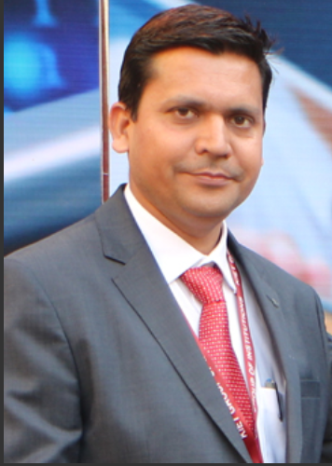
Dr. Ajay Kumar Shrivastava
Professor & Dean
The Department executes 4 years B.Tech. Degree Course. It has state-of-the-art & world class facilities, with a clear aim to be known as one of the best departments in Computer Science Engineering among all existing Indian colleges of repute.
The department has a strong team of faculty members with high dedication towards their commitment in teaching and research. I am sure the department will meet its vision and mission in the best manner.

